# Coursera IOT Devices Honors Assignment

The Picar 4wd was assembled per manufacturer’s instructions. See pictures of finished product below:

Wiring for each component was also connected per manufacturer’s instructions. See diagram below for details:

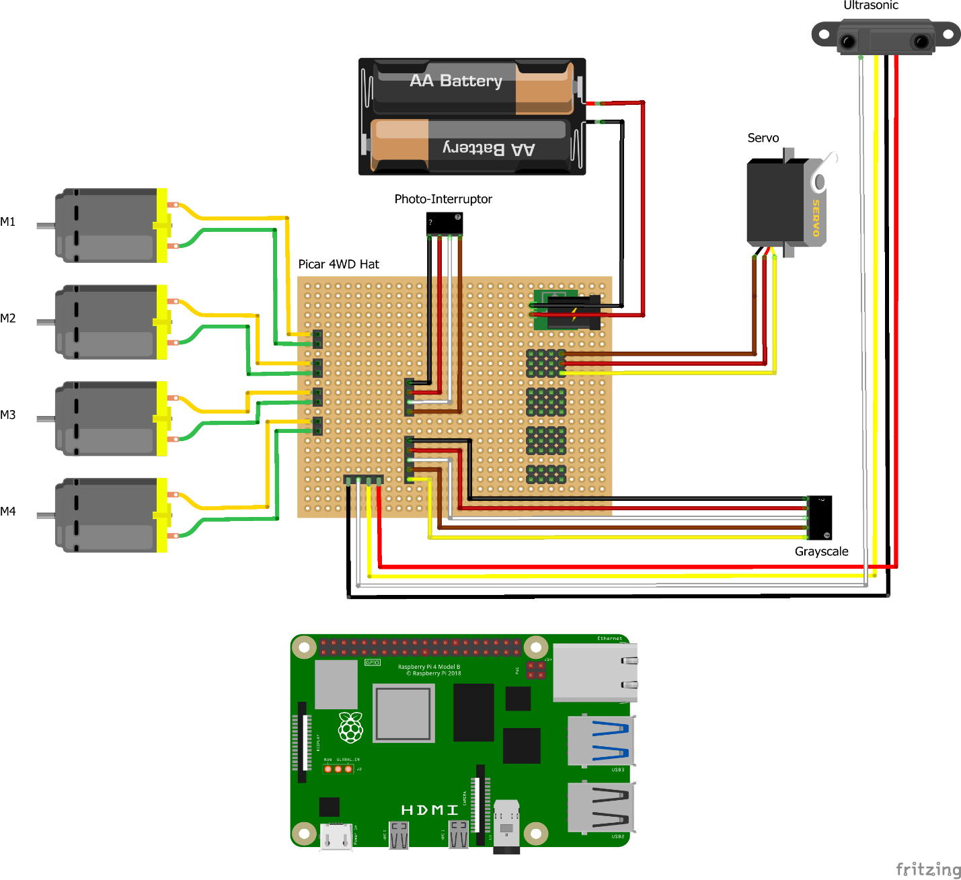

Figure : Picar 4WD Wiring Details

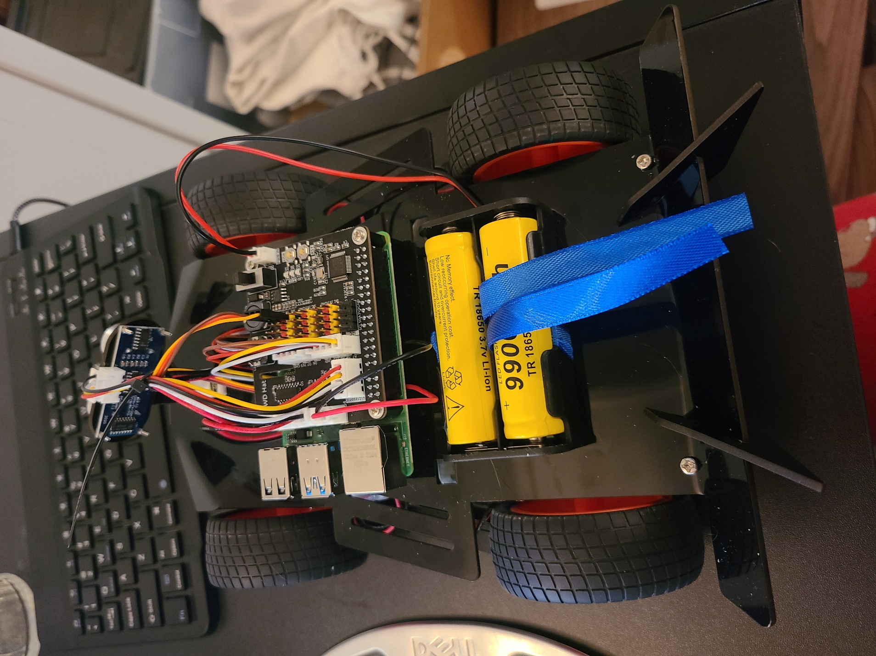

Figure : Picar 4WD Top View

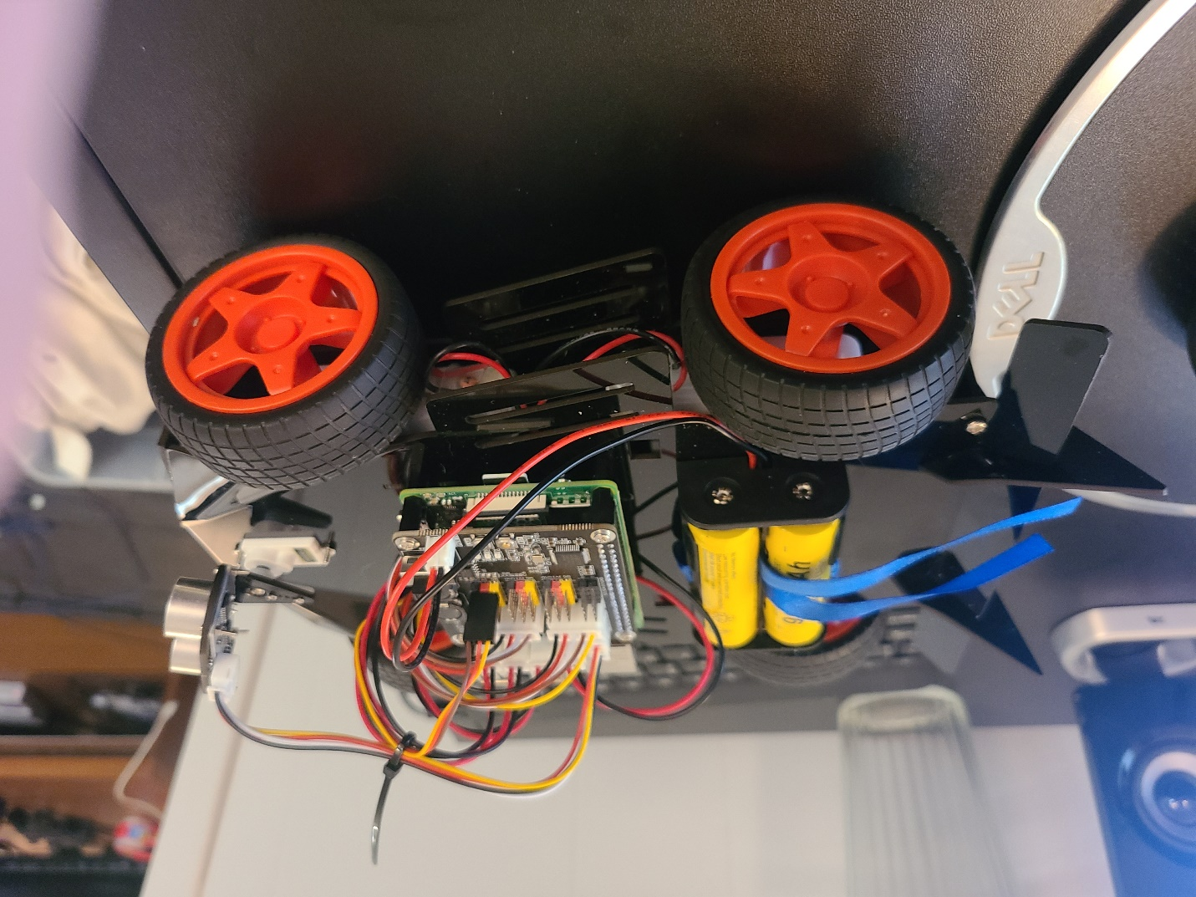

Figure : Picar 4WD Side View

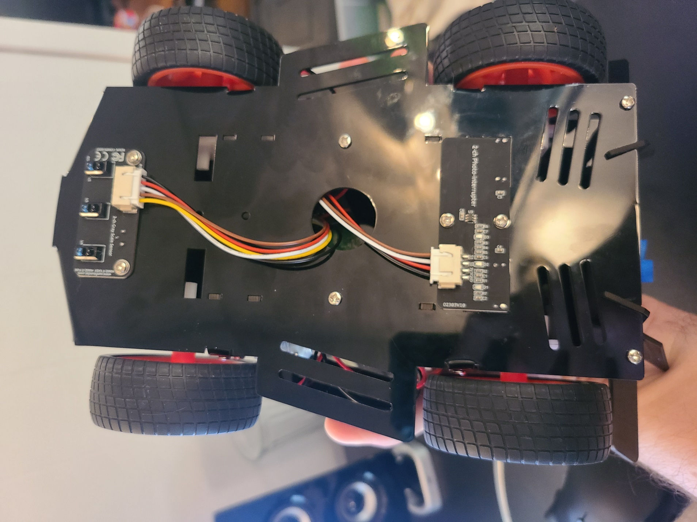

Figure : Picar 4WD Bottom View

Part 1 of the lab was all about assembling the car and setting up the Raspberry Pi.

Part 2 of the lab was to familiarize myself with the Picar programming and learn how to manipulate existing code and write new code to add/change functionality of the car.

The objective of Part 3 was to write an object detection and avoidance program for the car. The program should have the car scan for obstacles and upon detecting an obstacles in its path, stop, reverse and go around the obstacle.

Demo video is also attached to show the obstacle avoidance functionality.